My Master Plan

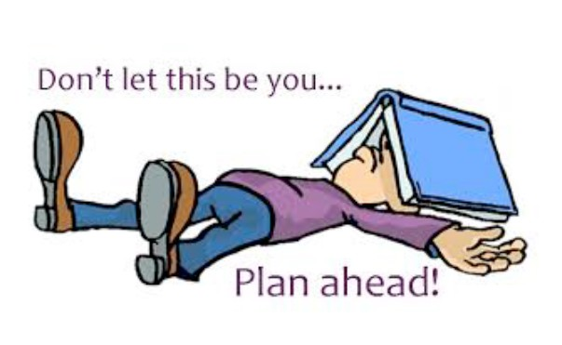

SWOT Analysis

S (Strengths) | W (Weaknesses)
O (Opportunities) | T (Threats)

It’s all about the experience...

Prelim Dos | Prelim Don’ts | Prelim Tips

Successful Revision is...

- Planned - A revision plan will make the best use of your time.

- Personal - Choose revision methods and times of day that work for YOU!

- Practical - Tailor your revision to the actual exam. Make sure you are confident about the types of questions which get asked and how long certain
questions should take you to complete. Get practice questions checked.

Looking forward...

Subject | Prelim Grade | Target Grade

Subject | Identified Next Steps (Target Setting)

GETTING THE GRADES

My Life -

Subject

Target
Record of work
Issues / Solutions

Subject

Target
Record of work
Issues / Solutions

Subject

Target
Record of work
Issues / Solutions

Subject

Target
Record of work
Issues / Solutions

Subject

Target
Record of work
Issues / Solutions

Subject

Target
Record of work
Issues / Solutions

R
A
G

Motivation/Rewards:

SQA Exam Diet 2018

Sun | Mon | Tues | Wed | Thur | Fri | Sat
30 | 1 May | 2 | 3 | 4 | 5 | 6
7 | 8 | 9 | 10 | 11 | 12 | 13
14 | 15 | 16 | 17 | 18 | 19 | 20
21 | 22 | 23 | 24 | 25 | 26 | 27
28 | 29 | 30 | 31 | 1 June | 2 | 3
4 | 5 | 6 | 7 | 8 | 9 | 10

GETTING THE GRADES

Week Ahead Exams:

[Aim for three - four blocks of revision a day. Don’t overdo one subject in a day]

Revision - Remember keep it...Planned, Personal and Practical

 | 8-10 | 10-12 | 12-2 | 2-4 | 4-6 | 6-8 | 8-10
Sat
Sun
Mon
Tues
Wed
Thurs
Fri

Be specific - Rather than plan to revise Biology, be specific (which topic?)

My Life:

Motivation/Rewards:

Where to start?

Use this section to create a checklist of topics to revise for each subject. You could traffic light both subjects and topics to help prioritise your revision.

Subject: | Subject:
Subject: | Subject:
Subject: | Subject:

Quick Questions

Use this page to record any questions that come up during your revision this week. Then make sure to make the time to check in with your class teacher.

Subject | Question(s)

